# Unit Testing

## Document Approval

|  |  |  |  |
| --- | --- | --- | --- |
| **Test ID** | **Test** | **Expected Outcome** | **Actual Outcome** |
| 1 | * Approval property shown in table | * On site launch, table features property displaying approval status of each document | * Passed |
| 2 | * Only approved users can change the approval property | * The admin page will have the option to approve certain documents | * Passed |
| 3 | * Date, time and name stored of user who approved the document | * When approved, the document will have information on the approval available to all users | * Failed |

**Test ID: 1 & 2**

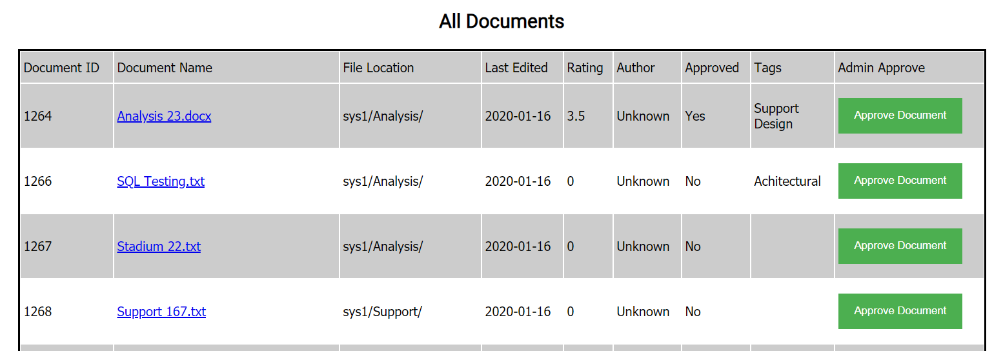

## Search/Indexing

|  |  |  |  |
| --- | --- | --- | --- |
| **Test ID** | **Test** | **Expected Outcome** | **Actual Outcome** |
| 10 | * Searching via document ID * Using 1264 (a document that exists) * Using 126 (a set of documents) * Using 9999 (a document that doesn’t exist) | * 1264 should return the single document with that ID * 126 should return all documents with an ID starting 126 * 9999 should return an error message about the lack of results | * 1264 - Passed * 126 - Passed * 9999 - Passed |
| 10.1 | * Searching via document name * Using existing document name (SQL Testing) * Using non-existent document name | * ‘SQL Testing’ should return any documents with it in the name * Random typing should return no results | * SQL Testing - Passed * Random string- Passed |
| 10.2 | * Searching via location * Use existing location * Use non-existent location | * ‘/Analysis’ should return all files in said file location * ‘/ghjkl’ should return none | * /Analysis - Passed * /ghjkl - Passed |
| 10.3 | * Search via last edited date | * ‘2020-01-16’ should return all files edited on this date | * 2020-01-16 - Failed, no results returned, the search operation won’t accept hyphens as a character |
| 10.4 | * Search via author * ‘Unknown only currently available one | * ‘Unknown’ should return all documents with this author | * Unknown - Passed |

**Test ID: 10**

Test 1:

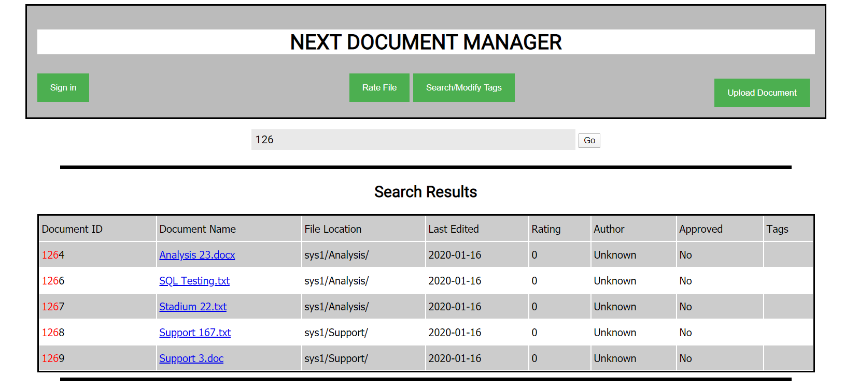

Test 2: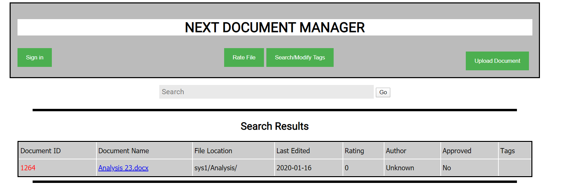

Test 3:



**Test ID: 10.1**

Test 1: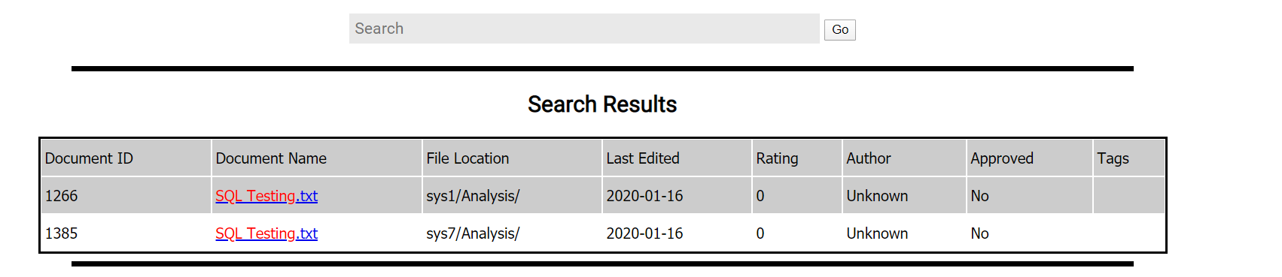

Test 2:

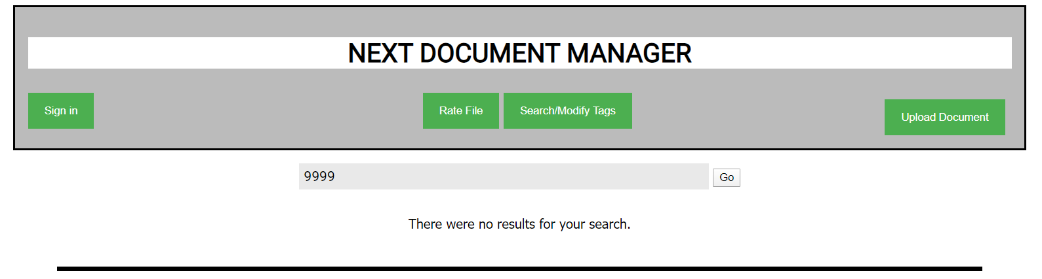

**Test ID: 10.2**

Test 1:

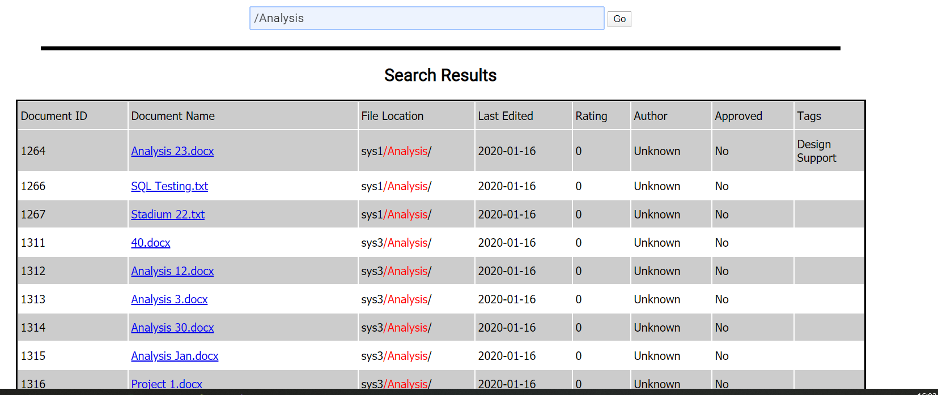

Test 2:



**Test ID: 10.3**

Test 1:



**Test ID: 10.4**

Test 1:

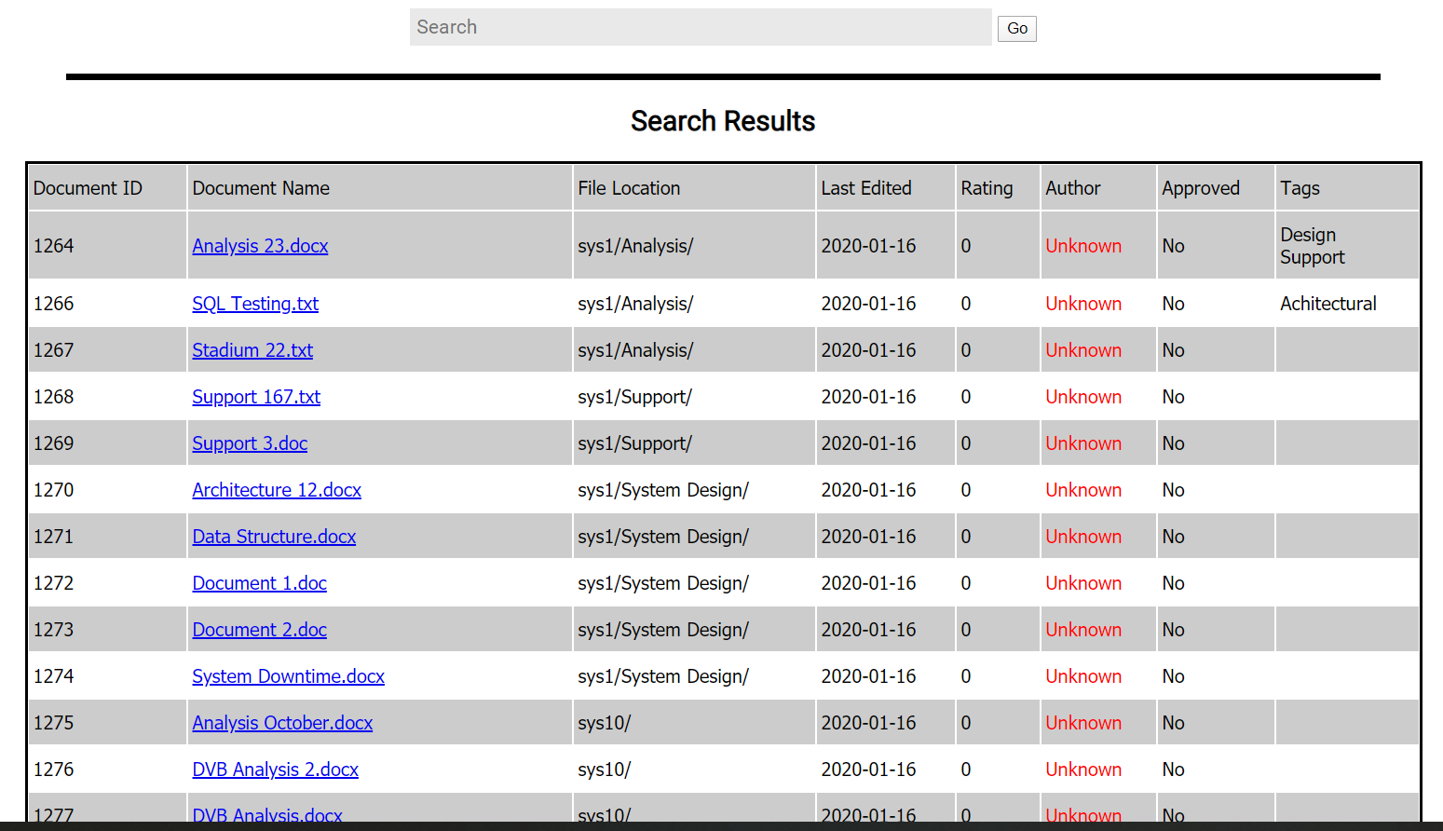

## Engine

|  |  |  |  |
| --- | --- | --- | --- |
| **Test ID** | **Test** | **Expected Outcome** | **Actual Outcome** |
| 20 | * Searching via document ID | * Once the ‘Go’ button is pressed, search results should be instantly available | * Passed - Results were instant, and correct |
| 21 | * Only allowed file extensions (doc, docx, txt) | * On the page opening, the documents in the table should only have the allowed extensions | * Passed - All featured documents meet the requirements |
| 22 | * An available path to see the root of the document | * On opening of the page, the file location should be available | * Passed - the file location is available when the website is opened |
| 23 | * Search criteria ordered by priority |  |  |
| 24 | * Search returns all properties of the file when included in search results | * When search results are returned, all properties of the file included | * Passed - all properties displayed |

**Test ID: 24**



# Test - categorization

|  |  |  |  |
| --- | --- | --- | --- |
| **Test ID** | **Test** | **Expected Outcome** | **Actual Outcome** |
| 30.1 | Can a user add a tag to a document  Enter doc ID “1264”  Enter tag ID “1” | The tag should be entered into the table  “Support” on  Doc Analysis_23 | The support tag was entered into the table atI d location 1264 - passed |
| 30.2 | Enter a invalid Doc ID  Enter Doc ID“1”  Enter tag ID “1” | The system should accept the ids however nothing will be added to database | Nothing is added as id “1” does not exist - passed |
| 30.3 | Enter a invalid Tag Id outside of the list  Enter doc id “1264”  Enter tag id “13” | The system will accept the Ids put nothing will be added to the valid doc id | Nothing is added as tag id 13 does not exist - passed |
| 30.4 | Can a user add multiple tags to a document  Enter Doc id “1264”  Enter TagID “5” | The system should accept the tag added and it should be added to the tags column when viewing the database | The system has both design and support as tags attached - passed |
| 30.5 | The user shouldnt be able to add multiple tags  Enter Doc ID “1264”  Enter Tag ID “5” | The system shouldn't accept/ show it on the database | The system should only have design and support as tags - failed  The tags on doc 1264 are  “Design” “Support” “Design” |
| 31 | Can a user delete a tag that has been added to a document in the system  Enter Doc ID “1264”  Enter Tag ID “1” | The system will accept the id and then delete the “support tag” in doc analysis_23 | The support tag was deleted from the tags section of the database  -passed |
| 32 | Can a user search through the database using the tags  Enter “Support” into the search box on the changetags page | The system shows all documents which have the support tag attached | The correct results were outputted to the user |
| 32.1 | Erroneous test  Searching for a value not in the list of tags  Enter “qqqqqq”  Into the search box on the changetags page | The system would not show any results | No results |
| 33 | Any user should be able to add new tags to the list  Add “Test 23” tag | The user should be able to add new tags to the list on the web page | The user can't add tags unless they have access to the database itself  Partial Fail - need admin details to complete |

## Test ID: 30.1

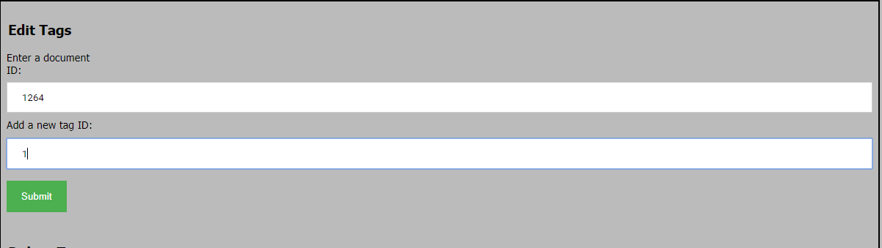



## Test ID: 30.2

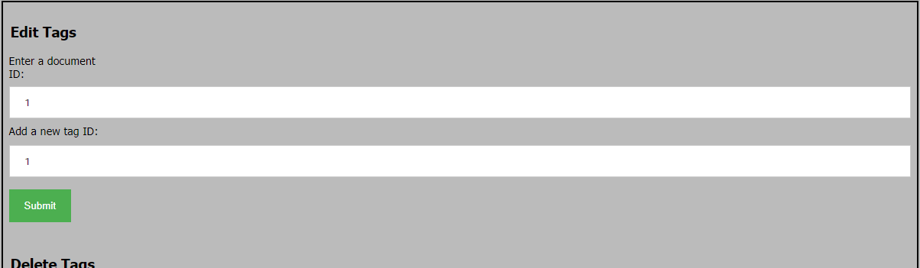

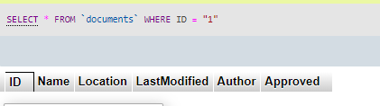no result in the database because doc id 1 does not exist

## Test ID: 30.3

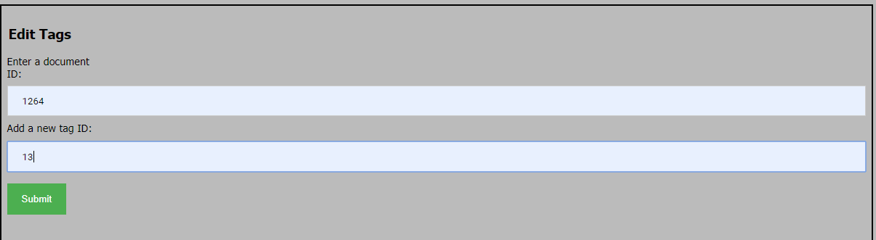

## Test ID: 30.4



## Test ID: 30.5

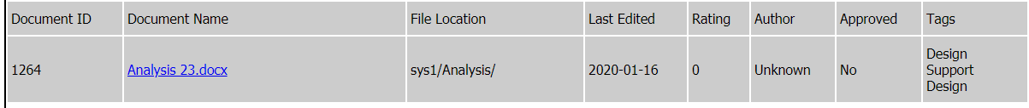

## Test ID: 31



Nothing added because tag id 13 does not exist

## Test ID:32

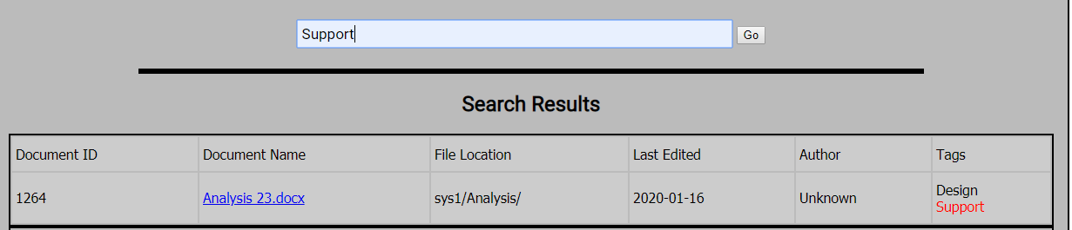

## Test ID 32.1



## Test ID 33

No current way to add tags without being a client

# Test - Rating System

|  |  |  |  |
| --- | --- | --- | --- |
| **Test ID** | **Test** | **Expected Outcome** | **Actual Outcome** |
| 40 | Can the user add a rating to a file  Click on the rate button  Enter “1264” doc id  Enter “2” rating value | The rating should be added to table and initial rating of 0 should be changed to 2 | The rating was set to 2  Passed |
| 40.1 | Try and add a rating when entering a invalid doc ID  Enter “100” doc id  Enter “2” rating value | The table shouldnt be updated as the doc id doesn't exist. | Nothing was added to table  passed |
| 40.2 | When multiple ratings are attached to a document does it calculate the averages  Enter another rating of “5” to doc ID “1264” | The rating should be changed to 3.5 (AVG of both rating attached to doc 1264 | The value stored in rating was 3.5  passed |
| 40.3 | Enter a rating value outside of the allowed range of 1-5  Enter “1270” Doc ID  Enter “6” Rating value | The rating shouldnt be added as its out of range | When a value out of the range is entered the user is told to enter a value in the range and the value isn't accepted  “Enter a value between 1 and 5”  passed |
| 41 | All rating should be 0 before a user adds a rating to doc  “Search for “1266” | The rating should be defaulted to 0 | The value in the rating column was 0 |

## Test id 40

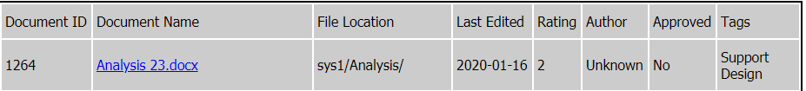

## Test id 40.1 ( searching for doc id 100 to see the rating)

## test id 40.2

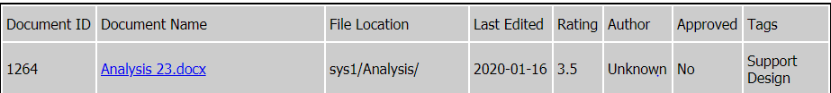

## Test id 40.3

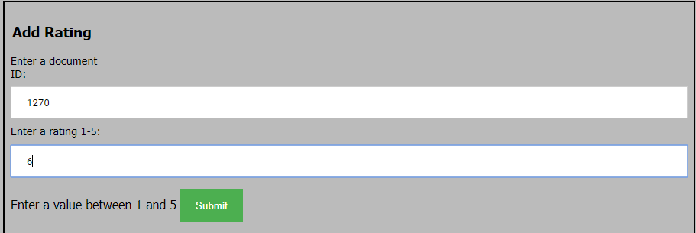

## Test ID: 41



**Upload System:**

|  |  |  |  |
| --- | --- | --- | --- |
| **Test ID** | **Test** | **Expected Outcome** | **Actual Outcome** |
| 42 | A user should be able to press the “Upload Document” button and be taken to the upload page. | The page changes to the upload page. | The page changes to the upload page. |
| 43 | A user should be able to press the “Back” button to return to the main page. | The page should reload to the main page. | The page reloaded to the main page. |
| 44 | A user should be able to type text into the Filepath and Author boxes. | Text appears in the boxes and can be added/removed in the same ways as usual. | Text appears and can be manipulated as usual. |
| 45 | A user should be able to click the “Choose File” button and be shown a file explorer window, | The file explorer will appear when the button is pressed. | The file explorer appeared when the button was pressed. |
| 46 | The chosen document should have its name appear next to the “Choose File” button. | The documents name will appear. | The document name appeared. |
| 47 | A user should be able to press the “Upload” button and their file and all entered data will appear in the list. | The page should reload and the main page should have the newly added document. | The new document appeared at the bottom of the main page. |

Test ID 42:

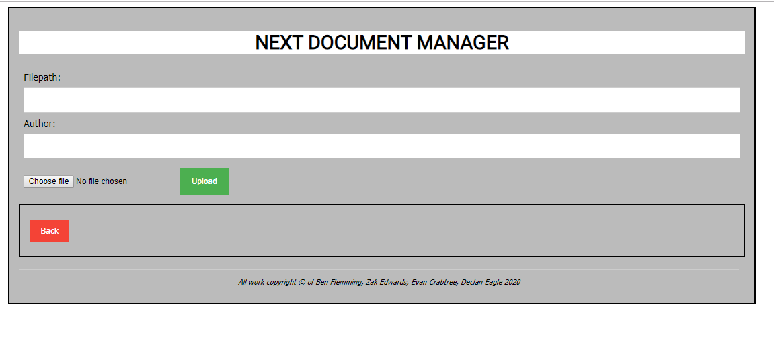

Test ID 43:

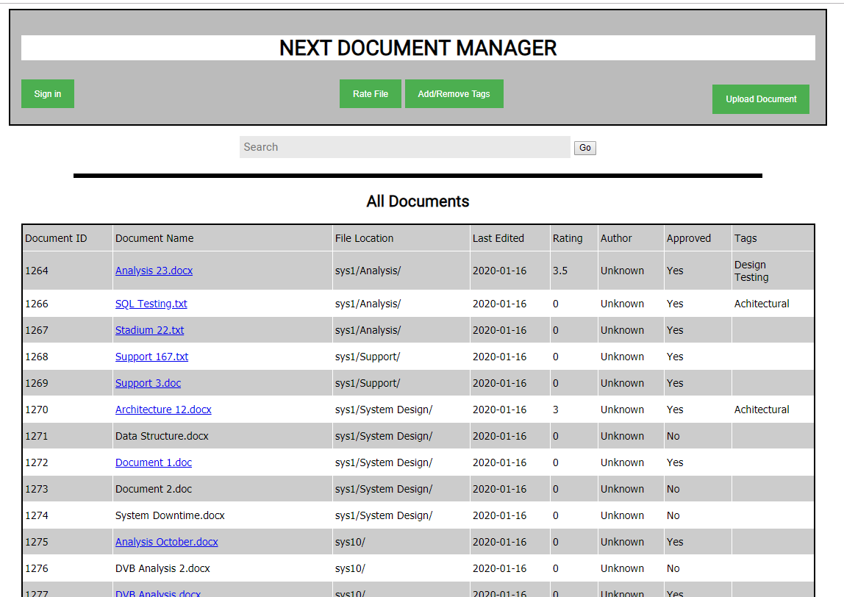

Test ID 44:

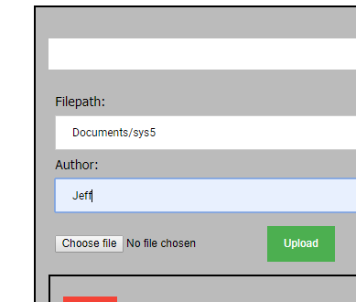

Test ID 45:

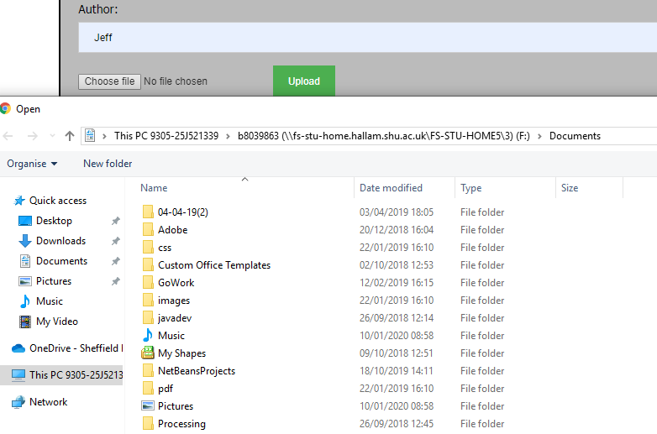

Test ID 46:

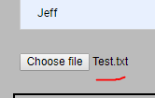

Test ID 47:

